Screen Sense – Analysing Kids’ Screen Time Patterns

Project Overview: Screen Sense –
The Screen Sense project aims to analyse and visualize children’s screen time behavior to uncover meaningful trends by age, gender, location type (urban/rural), device type, day of the week, and activity category (educational or recreational). The primary goal is to convert raw screen usage data into actionable insights that can help parents, educators, and policymakers promote balanced and healthy digital habits among children.
Project Statement
The project focuses on discovering patterns in children’s daily screen time and understanding how these vary across demographics and contexts. Using data visualization and exploratory data analysis (EDA), the aim is to identify:
- How screen time differs by age and gender.
- Whether urban or rural environments affect device usage.
- How device type (mobile, tablet, TV, Laptop etc.) influences time spent.
- Differences in screen activity across weekdays vs weekends.
- The proportion of time dedicated to educational vs recreational use.
These insights are communicated through visual dashboards and summary reports designed for non-technical stakeholders, ensuring the results are interpretable and actionable.

Expected Outcomes
By the end of this project, the following deliverables are expected:
- Data Understanding & Preprocessing – Clean and preprocess the dataset by handling missing values, duplicates, and inconsistencies.
- Exploratory Analysis – Explore data patterns related, Health Impacts, device usage, and other categories.
- Data Visualization – Create visual representations such as bar charts, heatmaps, and distribution plots to reveal key insights.
- Stakeholder Insights – Summarize findings in an easy-to-understand visual report/dashboard suitable for presentation.
- Final Presentation – Deliver key findings supported by data visuals and interpretation.
Milestone 1: Data Foundation and Cleaning
Week 1 – Project Initialization and Dataset Setup
This milestone laid the foundation for the project by focusing on dataset understanding and data quality improvement.
The following steps were completed:
- Defining Goals and Workflow :
  - Established project objectives aligned with analysing screen time patterns.
  - Created a structured workflow: data loading → exploration → cleaning → visualization.
- Loading the Dataset :
  - Imported the dataset using Python libraries such as pandas.
  - Verified data size, structure, and column information using commands like:
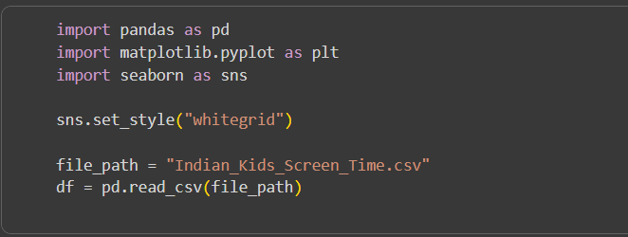
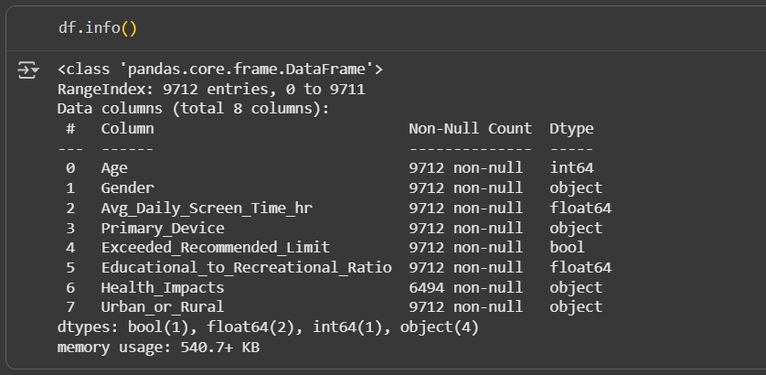
- Handling Duplicates and Identifying Null Values :

- Formula for identifying Null Values.
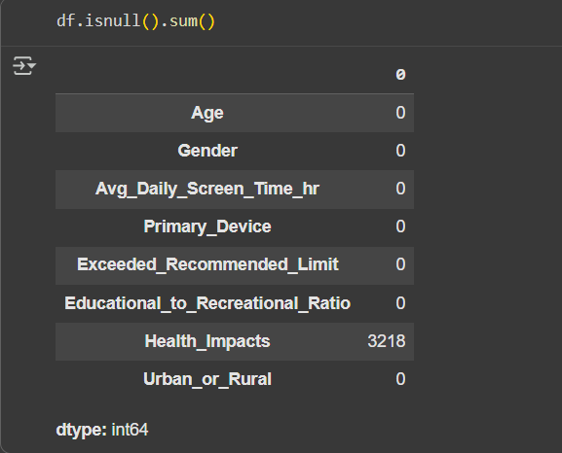
- Formula for identifying Duplicates value and removing it from file.
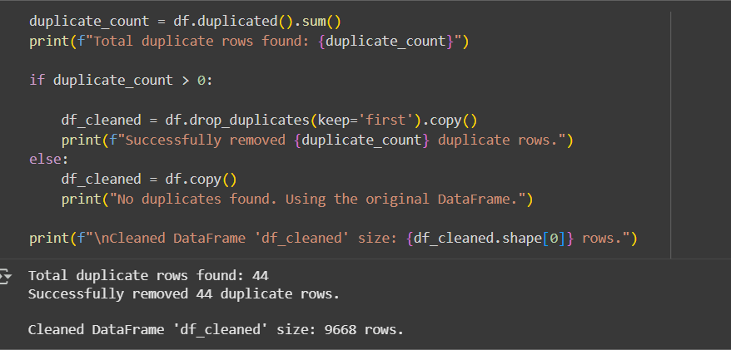

- Finding and Identifying some Core Descriptive Insite’s :

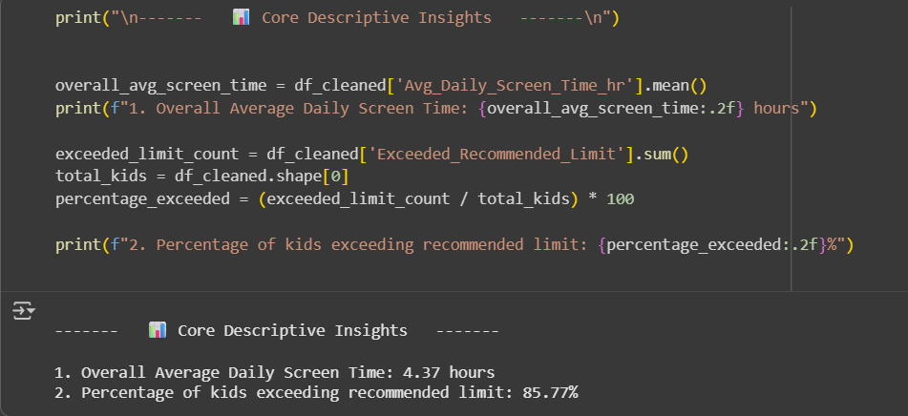

- Basic Data Visualization Using Colab / Jupyter Notebook :

- Frequency of Reported Health Impacts with Number of Kids Affected ->
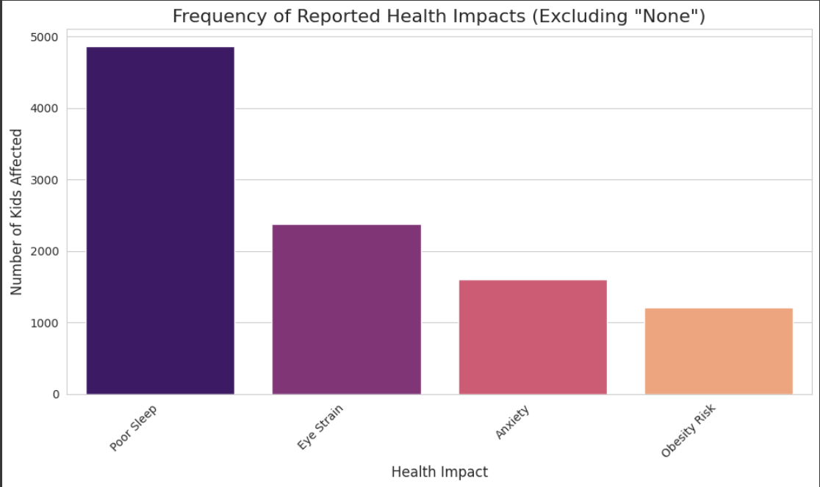

- Average Use of Primary Device by Age ->
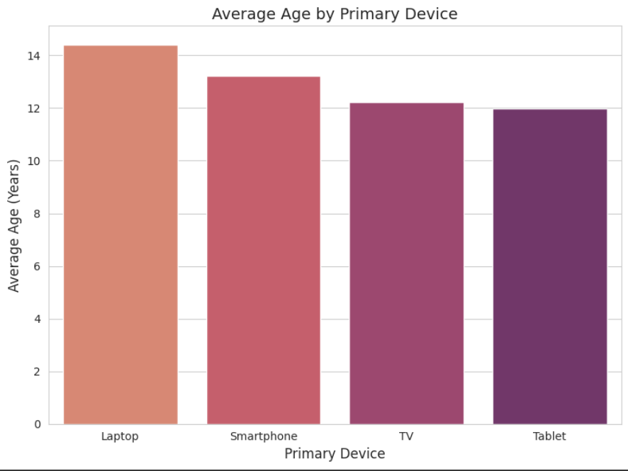

- Pie Chart Representation of the Comparison of Urban and Rural Kids Screen Time ->
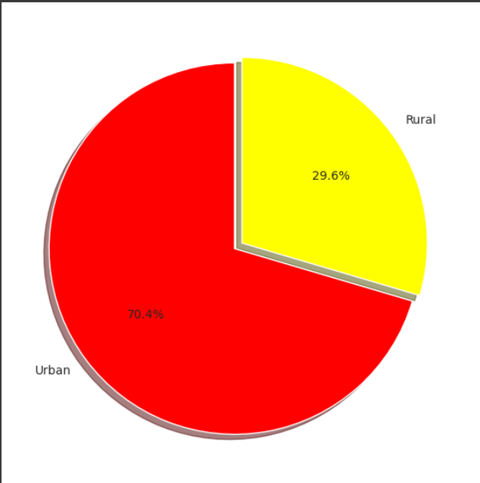

- Comparison of Average Screen Time with Gender ->

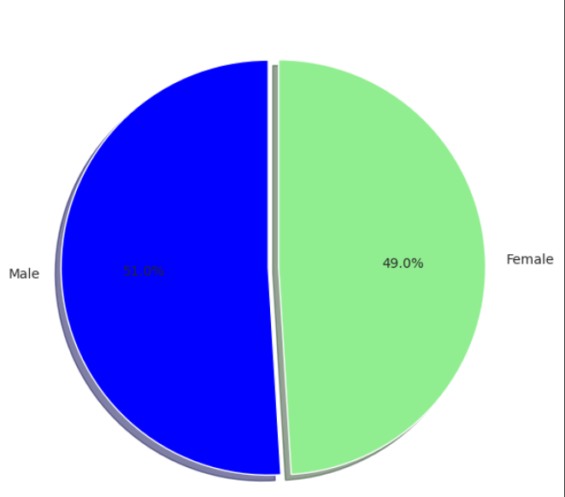

- Working with Excel :
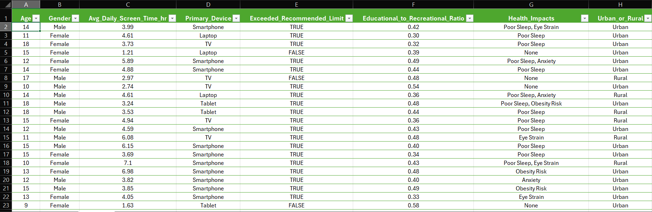

- Including some Valuable Columns for further Visualization :
